Git challenges
01: Resolve Merge Conflicts
Create a merge conflict intentionally (two users editing the same line).
Resolve the conflict and push the changes.

Ans: first need to connect with repository once it got connected need to create a file in two different branches and the content need to be quiet different and use the command to merge (git merge branch name)
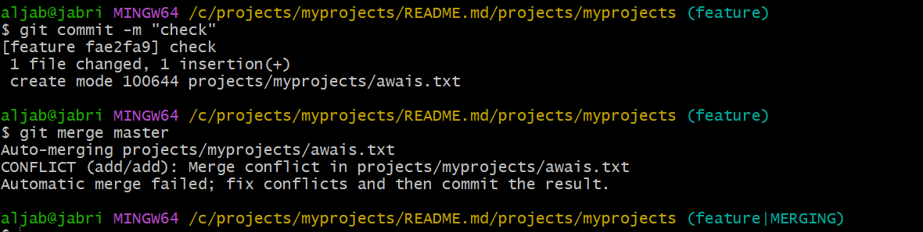
And to able to resolve the conflict need to edit the file and save it 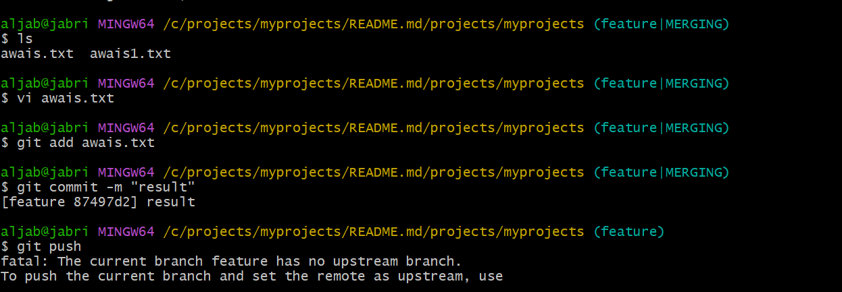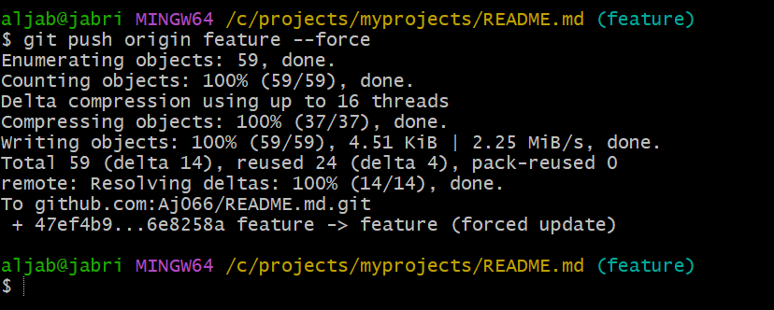

02: Recover Deleted Branch
Ans: To able to delete the branch need to use the command (git branch -D name)once it got delete to able to recover the branch(git checkout -b branch name del id) 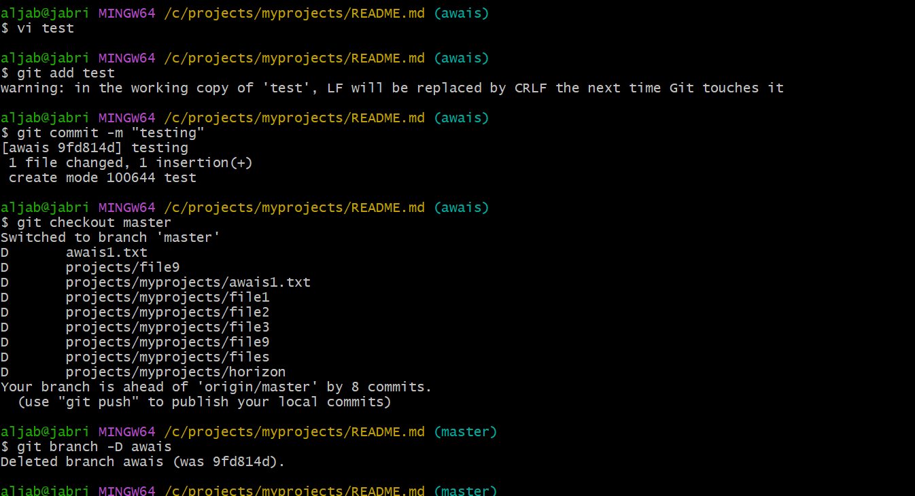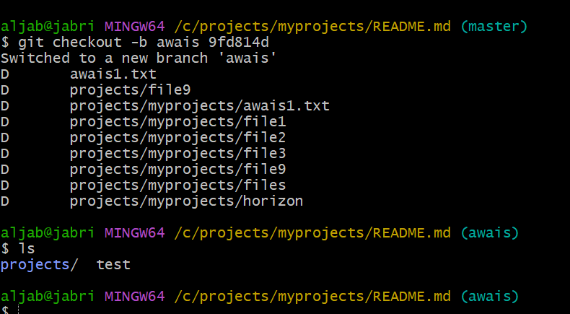

- 03: Undo Wrong Push
Push a wrong commit to GitHub, then undo it without losing history.
Ans: first need to push to central to able to undo need to use command of (git revert log it) 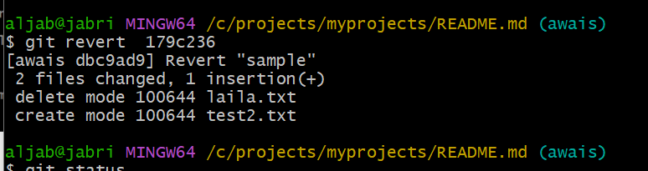
04: Amend a Commit
Make a commit, then add a missing file to it using git commit --amend.
Ans: first need to create a sample file and add to tracking area and add commit by using (git commit -m “message”)
once it get added need to use command for amend(git commit –amend ) 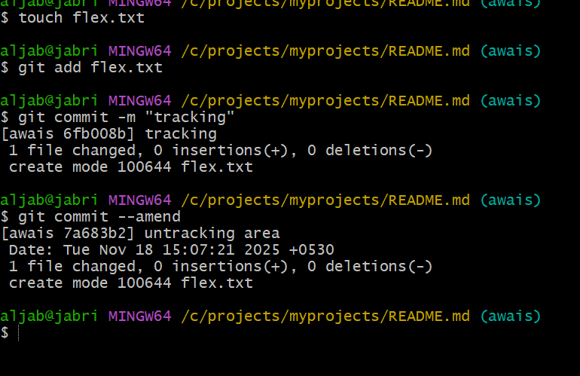

05: Cherry-pick a Commit:Take a specific commit from one branch and apply it to another branch
Ans: To able to use cherry pick in one branch one file is been there copy the log of that file and switch to another branch by using (git checkout branch name) once it got change need to use for cherry command (git cherry-pick log id)check the ls files will be get transfer
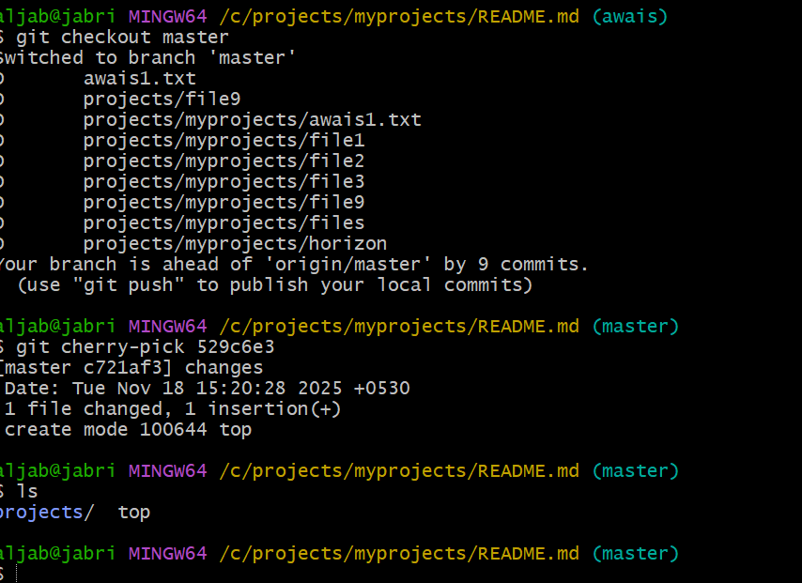
06: Interactive Rebase
.Reorder and squash multiple commits into a single clean commit.
Ans: step 1:got the commits in single line using git log –oneline command
step 2 :using git rebase -I head~5 command to list last five commits
Step 3: you will be redirected to vi/notepad++ editor in that replace the pick with squash
from second commit as shown in below picture
Step 4: then save the file
Step 5: check the log again then it will be in a single commit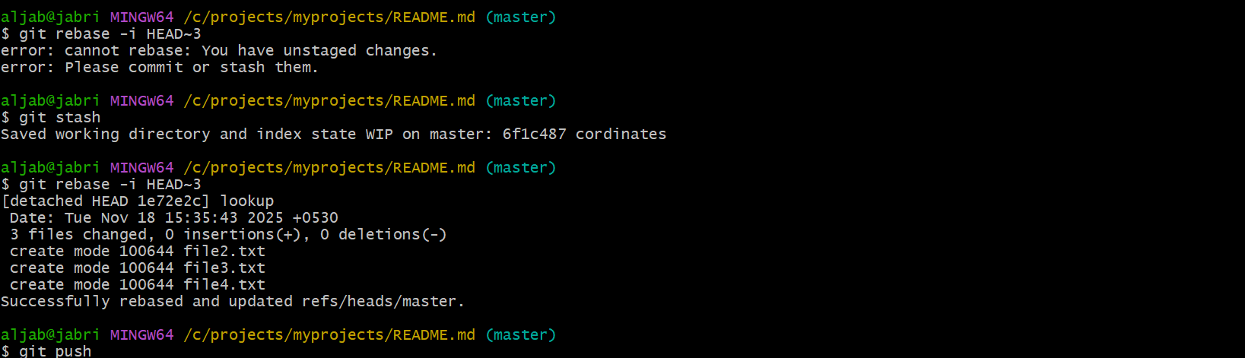

07: Tagging & Release Create a version tag (v1.0), push it to GitHub, then delete and restore it.
Ans: Create a version tag (v1.0)
We can tag the latest commits like bellow
git tag v1.0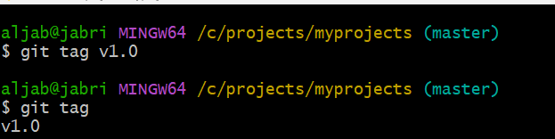
Then push the tag to GitHub use command
git push origin v1.0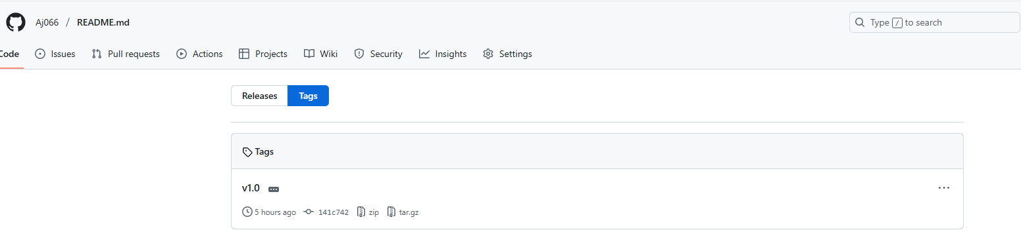
Delete the tag locally use command
git tag -d v1.0 ------ -d is used to delete
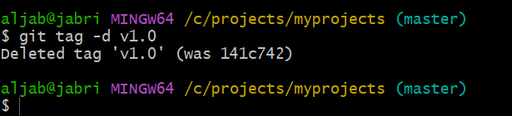
Now to delete the tag on GitHub use command
git push --delete origin v1.0 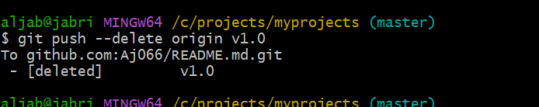
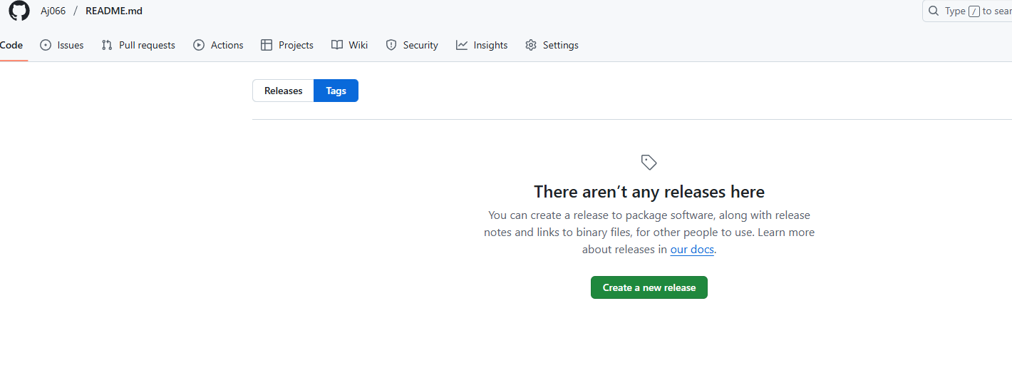
Since tags point to commits, restoring is easy. Just we need to recreate it again
To restore the tag use command
git tag v1.0
git push origin v1.0 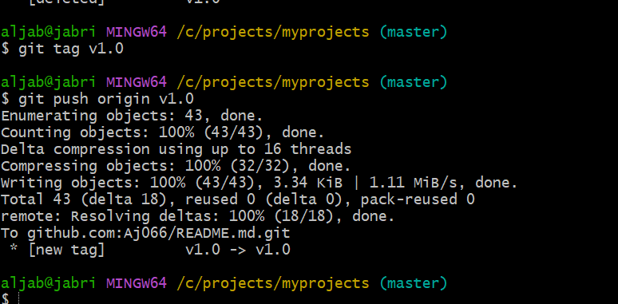

08: Clone with Sparse Checkout
.Clone only a subdirectory of a repo using sparse checkout.
Ans: Clone the repository without files we use command
git clone –-no-checkout <repo-url>
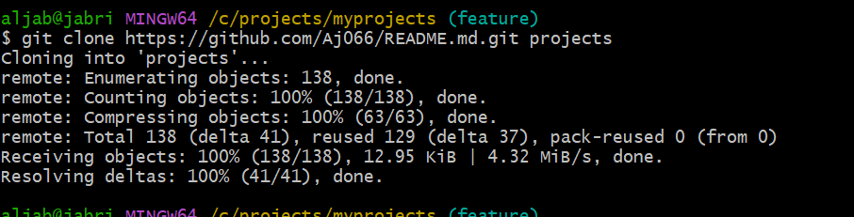
Enter the repository use command
cd practice ---- practice is repo name
Now enable sparse checkout use command
git sparse-checkout init --cone ----- this turns on sparse mode 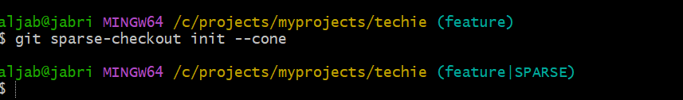
Now select the subdirectory you want use command
git sparse-checkout set folder1 ---- provide folder
Then pull the files from the GitHub use command
git checkout master ----- now git downloads only the selected folder

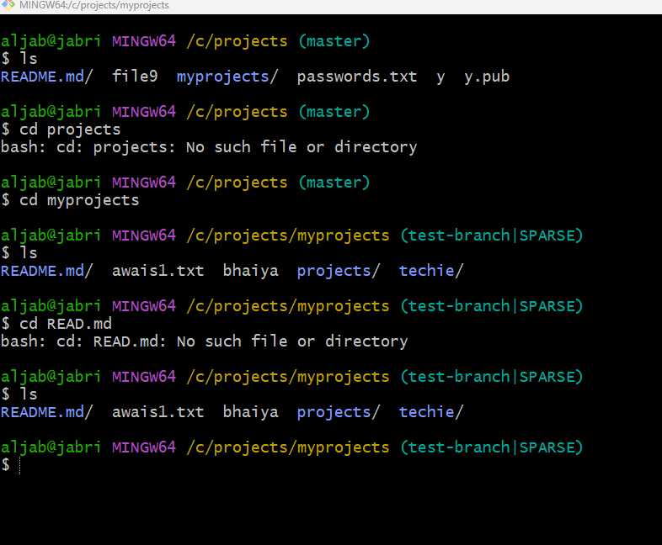
9.Reset vs Revert Challenge
Demonstrate the difference between git reset --hard and git revert in a repo.
Ans:
Git reset --hard :
----------------------
This removes commits from history and deletes the files
Reset to commit b ----- take the commit id of commit b
git reset --hard <commit b id>
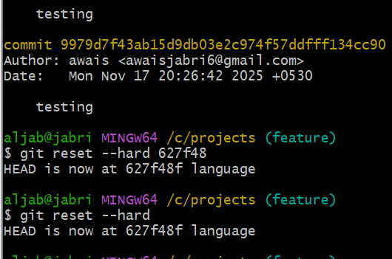
After reset commit disappears from history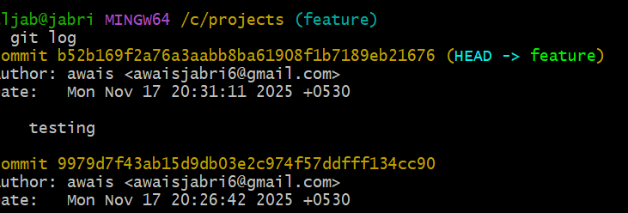

Git revert : git revert is a safe way to undo changes in Git, because it does not delete history. Instead, it creates a new commit that reverses the changes made by an earlier commit.
need to use recent commit (git revert head)
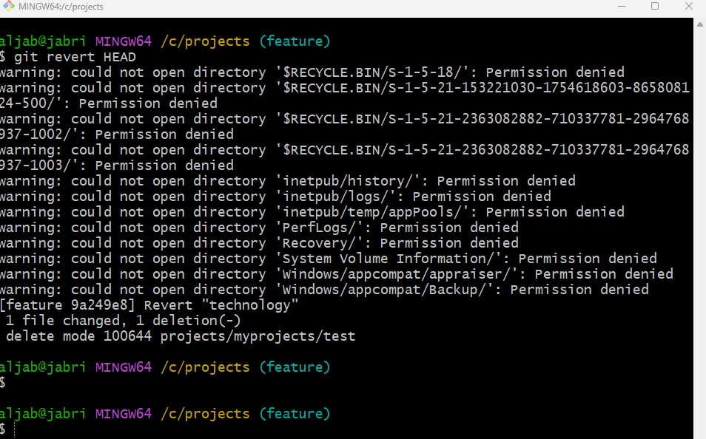
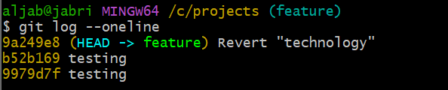

10: Detached HEAD Challenge
- Checkout a specific commit (detached HEAD state) and create a new branch from it.
Ans: What is detached HEAD : it means you are not working currently working on a branch, but rather directly on a specific commit

View your commit history use command
git log --oneline
pick any commit u want to checkout
then git checkout <commit id>
This means you are now in detached HEAD state
You are not on any branch
If you make any commits here they are “floating commits”
They will be lost unless you create a branch

Now create a new branch from this point
“This is the main part of the challenge”
git checkout -b floating-branch
Now you are no longer detached, you have a proper branch
This branch starts from the old commit you selected, you can safely commit and push now

Make commit to test it:
echo “this branch starts from the older commit” > demo
git add demo
git commit -m “added demo file in branch from detached HEAD”
git push -u origin floating-branch ------ floating-branch is the branch name
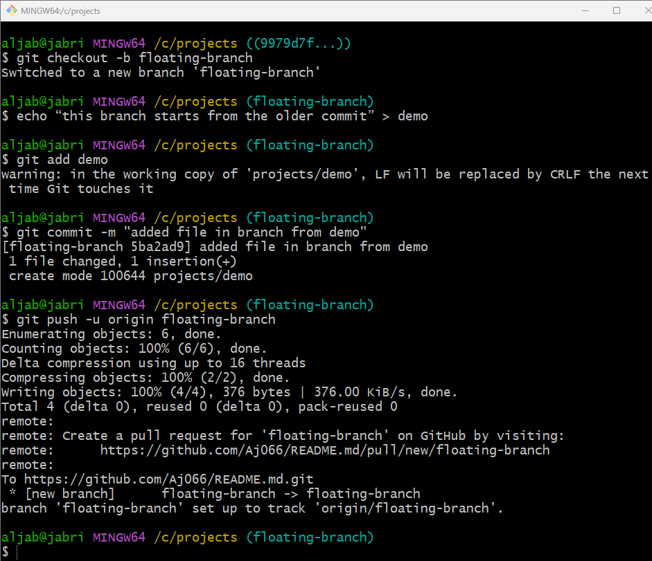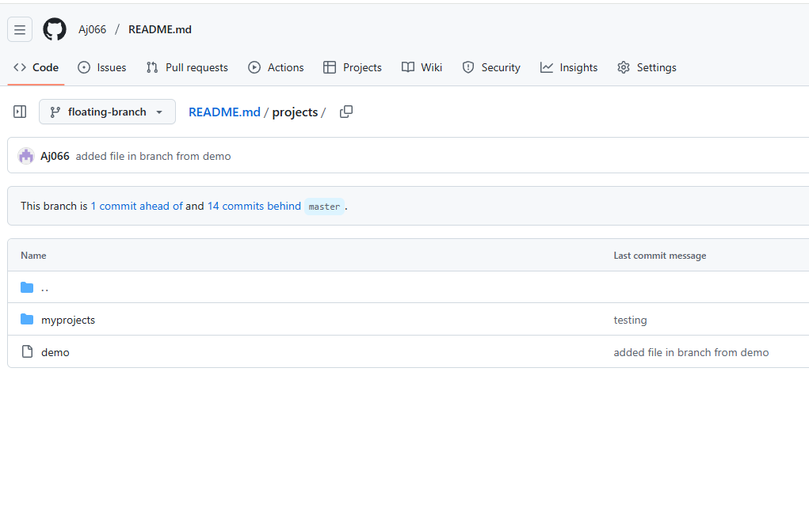11: Git Hooks Challenge
- Configure a pre-commit hook to reject commits without a message format (e.g., must start with JIRA-XXX).
Ans: pre-commit runs before the commit message editor opens, so it can’t read the commit message.
To validate the commit message, you must use commit-msg hook — not pre-commit.
Configure a pre-commit hook to reject commits without a message format (e.g., must start with JIRA-XXX).

Go to your repository
cd practice
Open the hooks directory use command
cd .git/hooks
create a new pre-commit hook file use command
touch pre-commit
Add this script inside pre-commit
#!/bin/sh
commit_msg_file=$(git rev-parse --git-dir)/COMMIT_EDITMSG
commit_msg=$(head -n 1 "$commit_msg_file")
if ! echo "$commit_msg" | grep -Eq "^JIRA-[0-9]+"; then
echo " ERROR: Commit message must start with JIRA-XXX"
exit 1
fi
exit 0
After allowing executable permissions to the pre-commit file
chmod +x pre-commit
git commit -m “JIRA-101: fixed login issue”
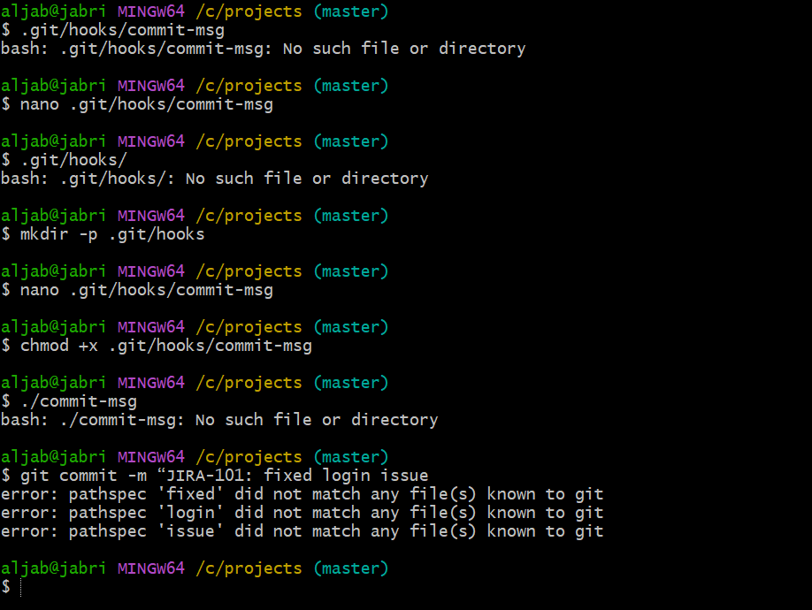
12: Squash Merge vs Rebase Merge
Show the difference between squash merge and rebase merge with evidence
Ans: Squash merge :
Create a feature branch and add commits to it use commands
git checkout -b feature ---- creates a branch and switch to it

echo “line1” >> test
git add test
git commit -m “added line1”

echo “line2” >> test
git commit -m “added line 2”
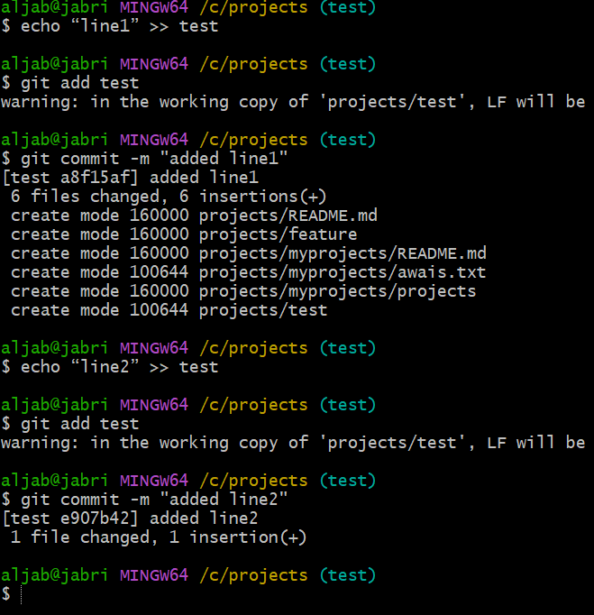
Now Switch back to main branch use command
git checkout master
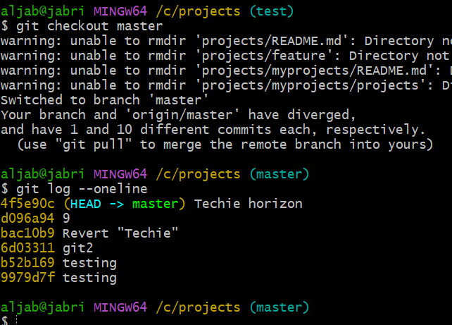
Squash merge the commits use command
git merge –squash feature
git commit -m “added lines 1 and 2 (squashed)”
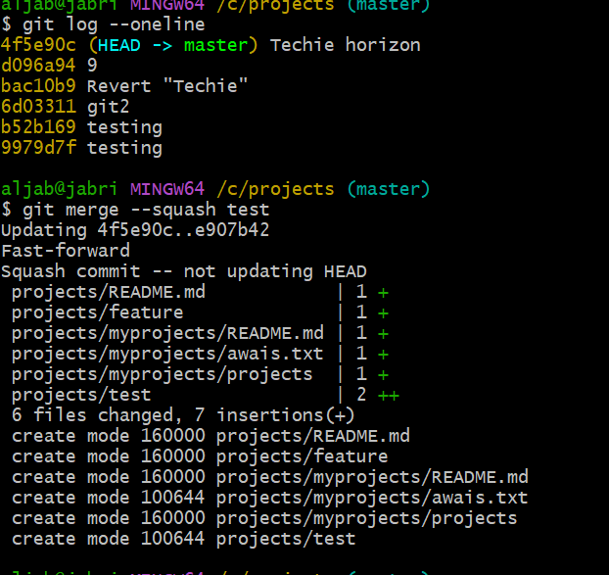
to see the commit history use command
git log –oneline
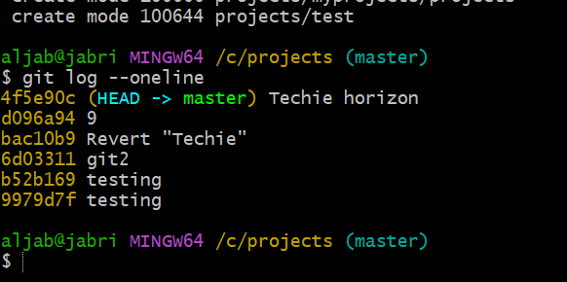
Rebase merge :
Switch to feature branch use command
git checkout feature
git rebase master ------- this replays the 3 commits on latest main
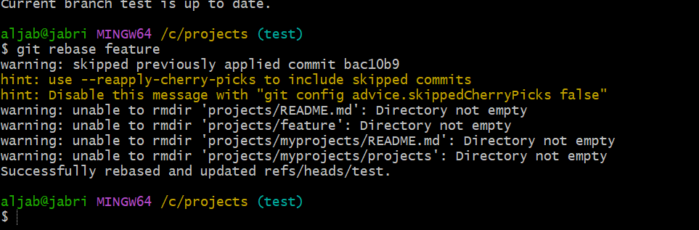Now switch to feature branch and merge test branch
git checkout feature
git merge test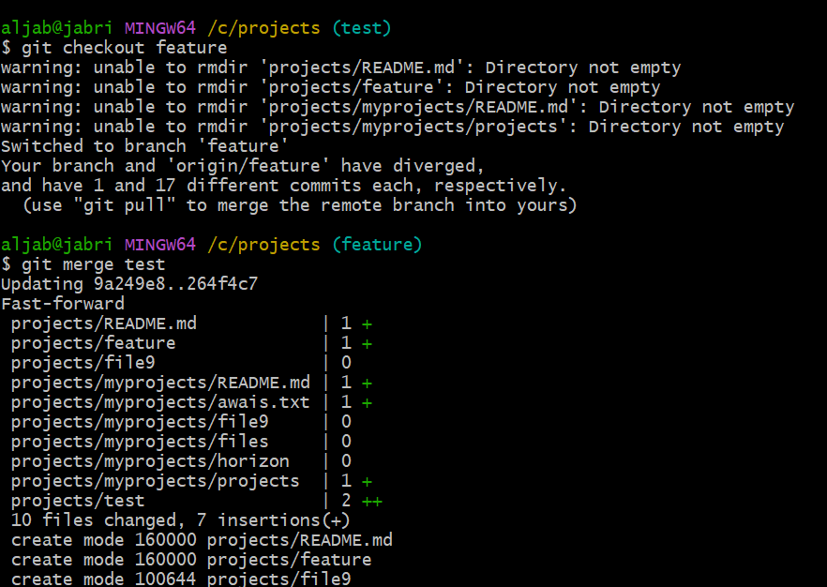
To see the commit history with graph use command
git log –oneline --graph
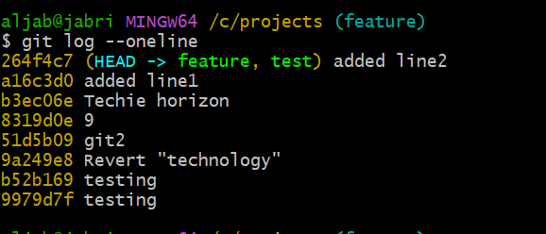

13: Fork & Pull Request Workflow
Fork a repo, make a change, and submit a pull request to the original repo.
Ans:
Fork the repository
First Clone your fork use command
git clone <url>
create a folder project
cd README.md

Then add upstream remote use command
git remote add upstream <url>

then switch to feature branch use command
git checkout feature

Then add and commit the changes using command
echo “hello from awais ” >> newfile
git add .
git commit -m "added newfile"
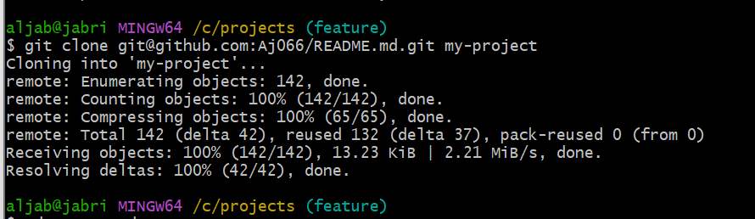
Then Push to your fork use command
git push -u origin feature 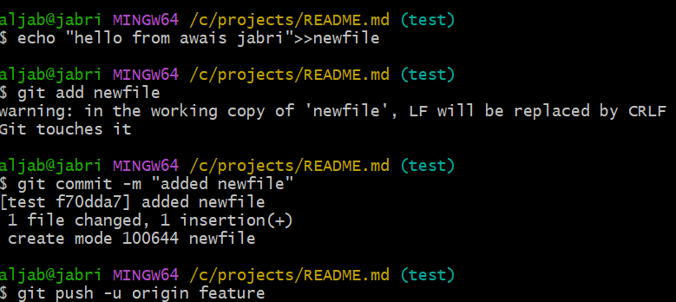
14. Recover Lost Commit
Commit something, reset hard, and then recover it using git reflog

Ans: Create a new file and commit id
echo “this is a secret commit” > secret
git add secret
git commit -m “added secret file”

Check your commit logs use command
git log –oneline
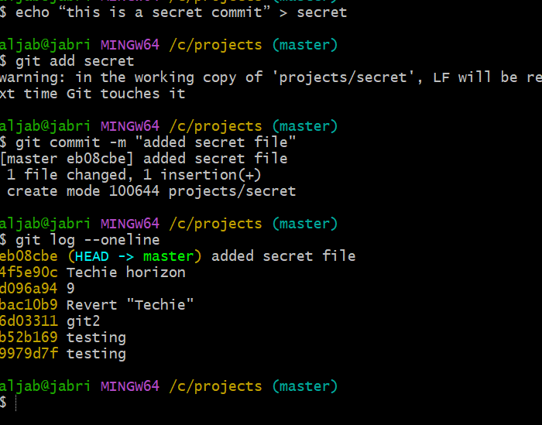

Now go back in history and loose commit
We will reset hard to previous commit use command
git reset –hard HEAD~1
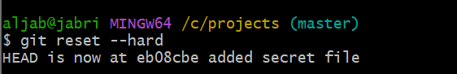
Then use git riflog to locate the lost commit
git reflog ----this command shows every moment of HEAD, even those removed by reset
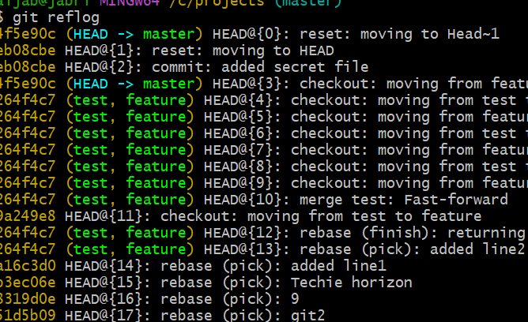
(find commit id of your lost commit)
Restore the commit as the head use command
git reset –hard <commit id>
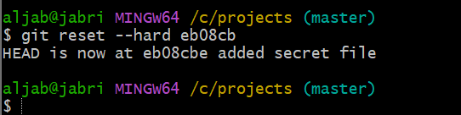

Verify recovery use command
git log –oneline
ls
